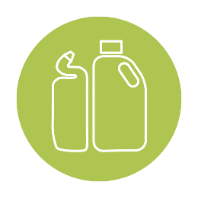
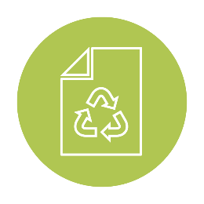
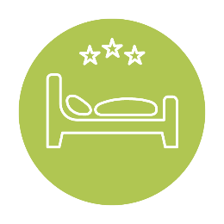
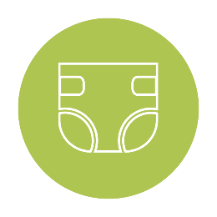
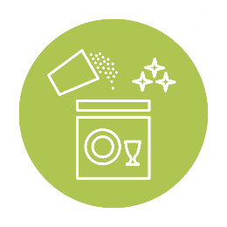

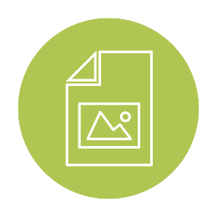
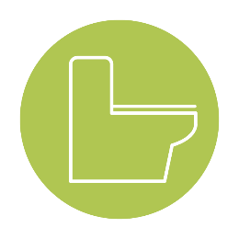
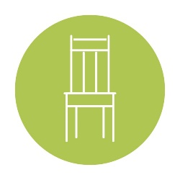
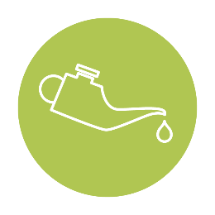
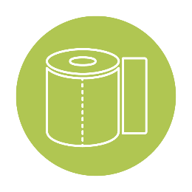
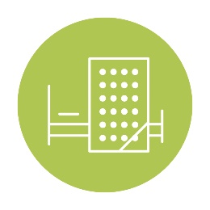
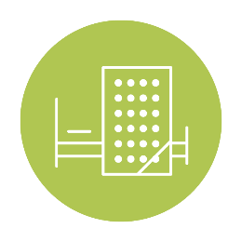

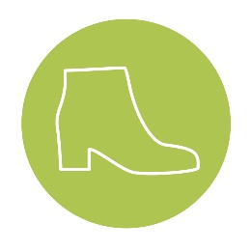

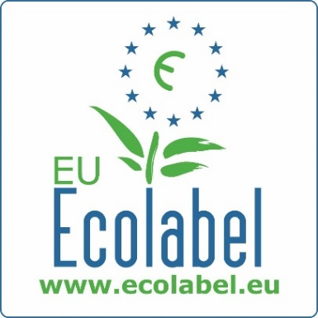
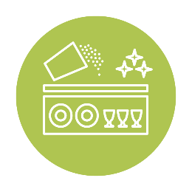

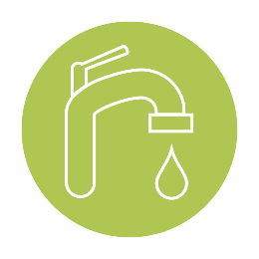
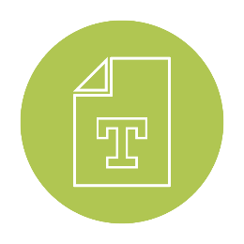
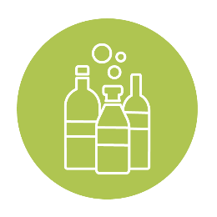
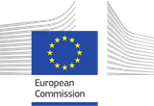
Furniture and bed mattresses

EU Ecolabel
NETWORK TOOLKIT

Funded by

September 2020

Network Toolkit – Furniture and Bed Mattresses – September 2020

Dear all,
Welcome to the September 2020 Network Toolkit. In this toolkit, you will find product-group specific communication content for Furniture and Bed Mattresses. Please find below instructions on how to best use this content:

WHY use this toolkit?
This content has been developed to provide you with ready-to-use material to facilitate communication on your own social media or website pages in order to collectively optimise outreach to our B2B and B2C target audiences. The Helpdesk posts all of the content listed within each toolkit on the official EU Ecolabel and EU Environment social media and website pages, however in order to have increased visibility of this content, we encourage you to publish this same material on your national social media and website pages, and share it with your partners and multipliers (such as NGOs, journalists or sustainability and lifestyle bloggers, etc).

HOW to use this toolkit?
This material can be used as-is (copy/paste), however depending on your country it may have the most impact if the content is translated into your national language and/or edited for your target audience. Make sure to follow and tag the EU Ecolabel LinkedIn account, the EU Environment Twitter (@EU_ENV) and Instagram (ourplanet_EU) accounts, when publishing on social media, so that we share your posts on our page.

WHAT material is in this toolkit?
The following content is available within this toolkit for you to disseminate:
- Ambassador Success Stories
- Social media posts for Twitter, Facebook, and LinkedIn
- Relevant hashtags and social media accounts to use and tag within the post
- Product-group specific articles

Feel free to send the Helpdesk feedback and suggestions concerning the toolkits —your comments will help improve their content.

Best wishes,
The EU Ecolabel Helpdesk Team

Content
I. Success stories: EU Ecolabel Ambassadors 3
II. Social media posts 5
III. Social media tags, links and influencers 11
IV. Article - EU Ecolabel: supporting EU Green Deal with less harmful chemicals for bed mattresses 12

Success stories: EU Ecolabel Ambassadors
NORTHERN EUROPE  Montana Furniture, Denmark | SOUTHERN EUROPE  Mobilferro, Italy
"Acquiring the EU Ecolabel has been very important to us, and it's something we've worked towards for a long time. I'm delighted that Montana is one of the first furniture manufacturers in Europe to achieve it because I consider sustainability a key part of our responsibilities as a furniture manufacturer in Denmark”  Joakim Lassen, Montana Furniture’s CEO  Montana Furniture is a Danish family-owned company that produces and supplies shelving systems, tables, and chairs for homes and modern office environments. In 2019, the company was awarded the EU Ecolabel for its shelves, becoming one of the very first Danish furniture manufacturers to achieve it. | “School chairs used by children potentially transmit harmful hazardous substances. Mobilferro’s furniture have restricted use of chemicals such as formaldehyde, solvents and flame retardants and act as a guarantee for safer products.”  Marco Canazza, Mobilferro’s Marketing and Contract Manager  The Italian company Mobilferro, awarded with the EU Ecolabel, manufactures eco-friendly furniture mainly for public schools. The company’s suppliers are carefully selected, and the internal laboratories closely monitored to directly verify the characteristics of the products.
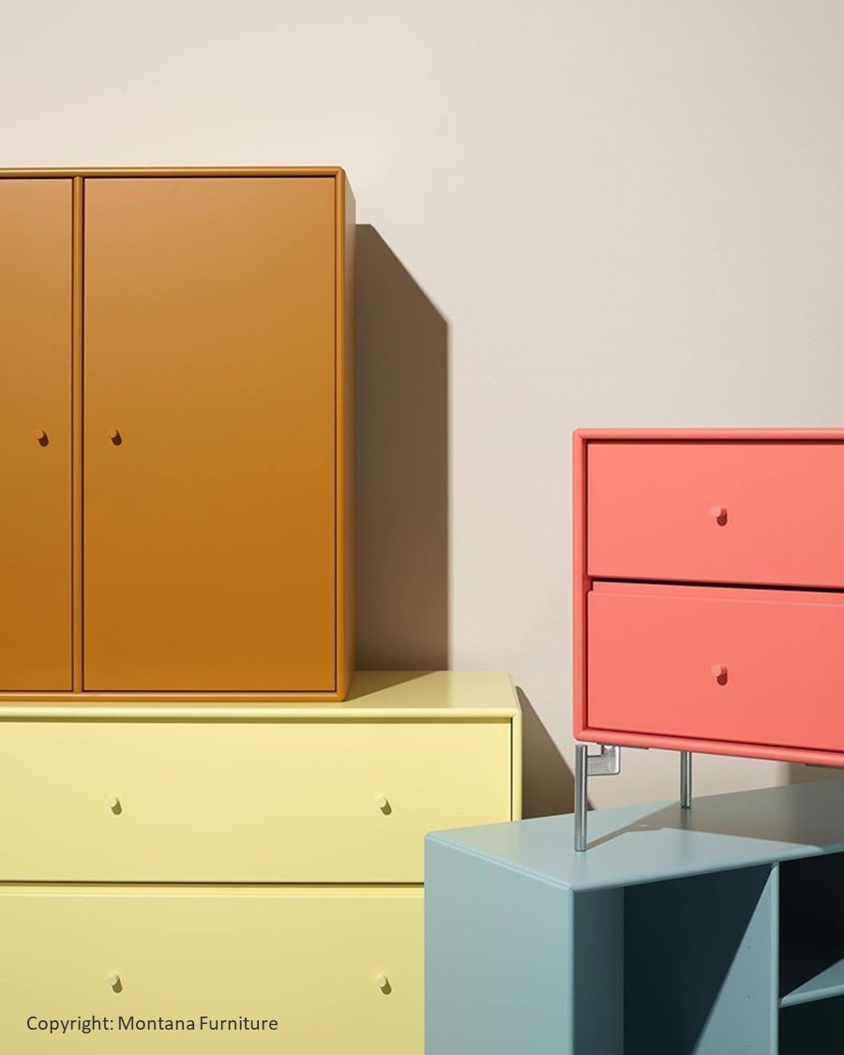 | 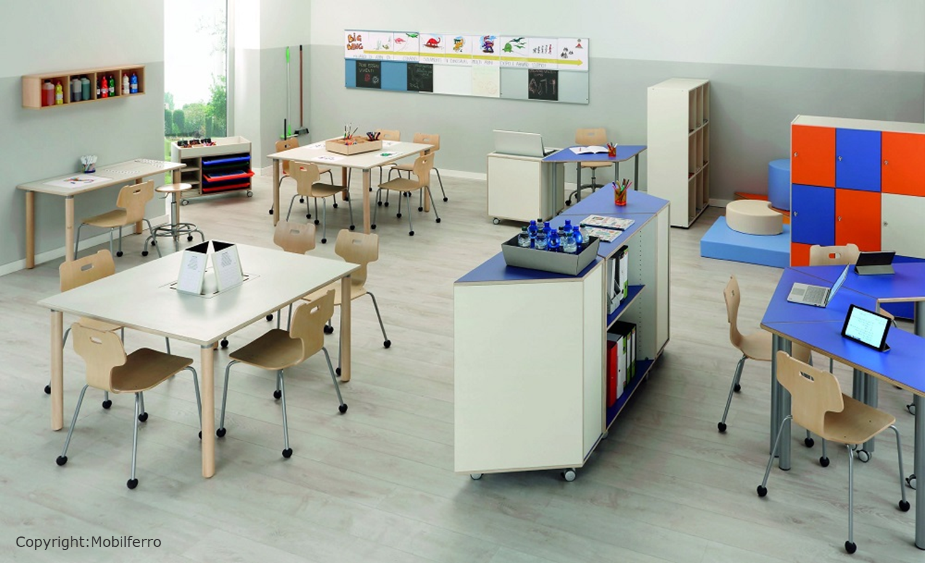

EASTERN EUROPE  InterierTech, Czech Republic | WESTERN EUROPE  Elite, Switzerland (Austrian CB)
“Acquiring the EU Ecolabel sends a strong message to our industry. It proves that caring for the environment and complying with controlled processes and demanding criteria such as the EU Ecolabel requirements is possible in our line of business.”  Jan, Project Manager InterierTech  As the only Czech furniture company awarded with the EU Ecolabel, InterierTech gained a competitive advantage with both private and public clients.  As part of its sustainable production, InterierTech recycles 30% of wooden materials. They strongly believe that strengthening their environmental performance is also economically beneficial for their business. | “The EU Ecolabel certification is one way consumers can buy safer and reliable products. The EU Ecolabel ensures high-quality and long-lasting products with restricted use of harmful substances.”  Francois Pugliese, Elite’s owner  Elite is a Swiss bed mattresses manufacturer certified with the EU Ecolabel since 2010. The company manufactures bedding with non-chemical materials, sourced as close as possible to the production factories, in order to limit the products’ carbon footprints.
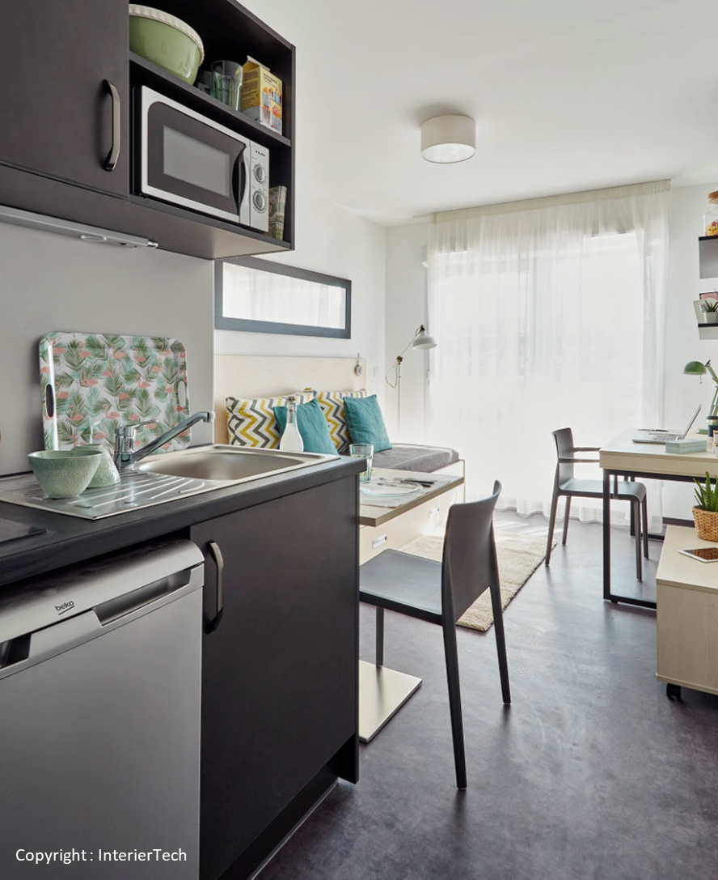

Social media posts

- Type of post & tags | Facebook / LinkedIn | Twitter | Visual
LH focus:  Elite  Tags:  #EUEcolabel  #CircularEconomy  #SustainableMaterials  # ProductLifeCycle | “The EU Ecolabel certification can guarantee that customers are buying safer and reliable products. The EU Ecolabel ensures high-quality and long-lasting products with restricted use of harmful substances.” Francois Pugliese, @Elite’s owner  @Elite is a Swiss bed mattresses manufacturer certified with the EU Ecolabel since 2010. The company manufactures bedding with a restricted use of chemicals, sourced as close as possible to the production factories, in order to limit the products’ carbon footprints.  More about Elite https://www.elitebeds.ch/fr/ | “The #EUEcolabel certification can guarantee that customers are buying safer and reliable products. The #EUEcolabel ensures high-quality and long-lasting with restricted use of harmful substances.” Francois Pugliese, @Elite’s owner, a Swiss bed mattresses manufacturer certified with the EU Ecolabel since 2010.
LH focus:  InterierTech  Tags:  #EUEcolabel  #CircularEconomy  #SustainableMaterials  #ProductLifeCycle | “Acquiring the EU Ecolabel sends a strong message to our industry. It proves that caring for the environment and complying with controlled processes and demanding criteria such as the EU Ecolabel requirements is possible in our line of business.” Jan, Project Manager @InterierTech  As the only Czech furniture company awarded with the EU Ecolabel, InterierTech gained a competitive advantage with both private and public clients. As part of its sustainable production, InterierTech recycles 30% of wooden materials. They strongly believe that strengthening their environmental performance is also economically beneficial for their business.  More about InterierTech https://www.interiertech.cz/ | “Acquiring the #EUEcolabel sends a strong message to our industry. It proves that caring for the environment and complying with controlled processes and demanding criteria such as the #EUEcolabel requirements is possible in our line of business.” Jan, Project Manager @InterierTech, a Czech furniture company. | 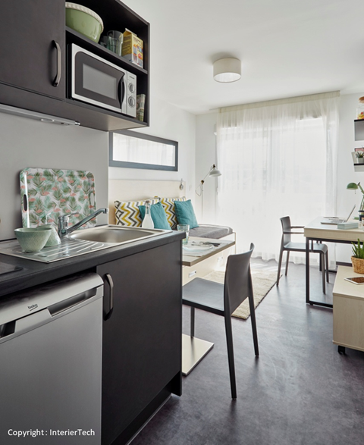
LH focus:  Mobilferro  Tags:  #EUEcolabel  #CircularEconomy  #SustainableFurniture  #SustainableMaterials | “School chairs used by children potentially transmit hazardous substances. @Mobilferro_Srl’s furniture have restricted use of chemicals such as formaldehyde, solvents and flame retardants and act as a guarantee for safer products.” Marco Canazza, @Mobilferro_Srl’s Marketing and Contract Manager  The Italian company @Mobilferro_Srl, awarded with the EU Ecolabel, manufactures eco-friendly furniture mainly for public schools that have very little formaldehyde. The company’s suppliers are carefully selected, and the internal laboratories closely monitored to directly verify the characteristics of the products.  More about Mobilferro https://www.mobilferro.org/ | The Italian company Mobilferro, awarded with the #EUEcolabel, manufactures eco-friendly furniture mainly for public schools that have very little formaldehyde. The company’s suppliers are carefully selected, and the internal laboratories closely monitored to directly verify the characteristics of the products.
LH focus:  Montana Furniture  Tags:  #EUEcolabel  #CircularEconomy  #SustainableFurniture  #SustainableMaterials | @Montana_Furniture is a Danish family-owned company that produces and supplies shelving systems, tables, and chairs for homes and modern office environments. In 2019, the company was awarded the EU Ecolabel for its shelves, becoming one of the very first Danish furniture manufacturers to achieve it.  "Acquiring the EU Ecolabel is very important to us. I'm delighted that Montana is one of the first furniture manufacturers in Europe to achieve it” Joakim Lassen, Montana Furniture’s CEO  More about Montana Furniture https://www.montanafurniture.com/fr | .@Montana Furniture is a Danish family-owned company that produces and supplies shelving systems, tables, and chairs for homes and modern office environments. In 2019, the company was awarded the #EUEcolabel for its shelves, becoming one of the very first Danish furniture manufacturers to achieve it. | 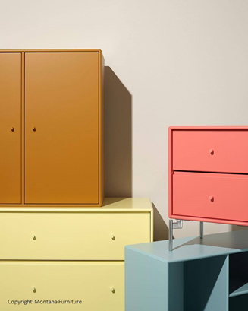
Current issue focus:  Sustainable materials for furniture  Tags:  #EUEcolabel  #CircularEconomy  #SustainableFurniture  #SustainableMaterials | #DidYouKnow? Wood, cork, bamboo and rattan used in EU Ecolabel furniture must be non-GMO and have a sustainable forest management label from an independent third-party certification system such as FSC.  Find out more about our furniture --> http://ec.europa.eu/ecat/ | #DidYouKnow? Wood, cork, bamboo and rattan used in EU Ecolabel furniture must be non-GMO and have a sustainable forest management label from an independent third-party certification system such as @FSC. | 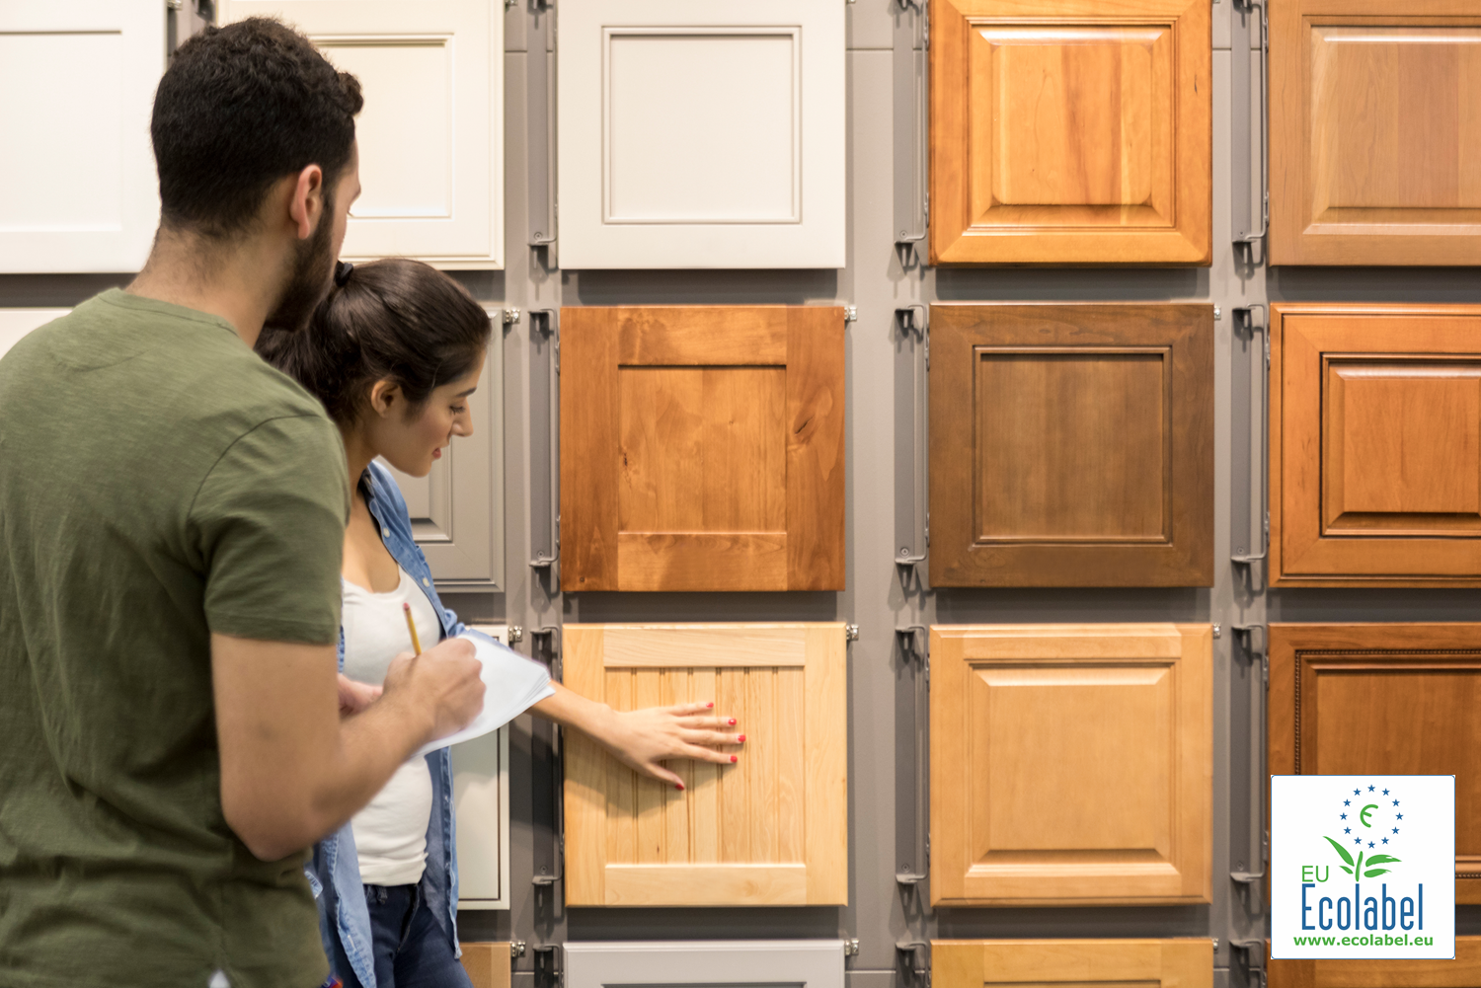
Current issue focus:  Sustainable furniture production  Tags:  #EUEcolabel  #CircularEconomy  #SustainableFurniture  #SustainableMaterials | The EU Ecolabel criteria aim to reduce the environmental footprint of furniture production and are aligned with the EU Green Public Procurement to make it easier for public organisations to purchase responsible furniture in Europe.  More about our furniture --> http://ec.europa.eu/ecat/ | The #EUEcolabel criteria are aligned with the EU Green Public Procurement, to make it easier for public organisations to purchase responsible furniture in Europe. | 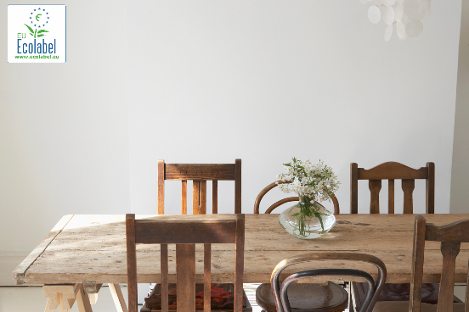
Current issue focus:  Technical performance of bed mattresses  Tags:  #EUEcolabel  #CircularEconomy  #SustainableMaterials  # ProductLifeCycle | Choosing an #EUEcolabel bed mattress means choosing a product that meets high quality standards, ensuring both its excellent performance and durability.  Durability criteria for the #EUEcolabel means products cannot lose height lower than 15% nor lose firmness lower than 20% over time, insuring long-lasting products.  Find out more about our bed mattresses --> http://ec.europa.eu/ecat/ | Choosing an #EUEcolabel bed mattress means choosing a product that meets high quality standards, ensuring both its excellent performance and durability. | 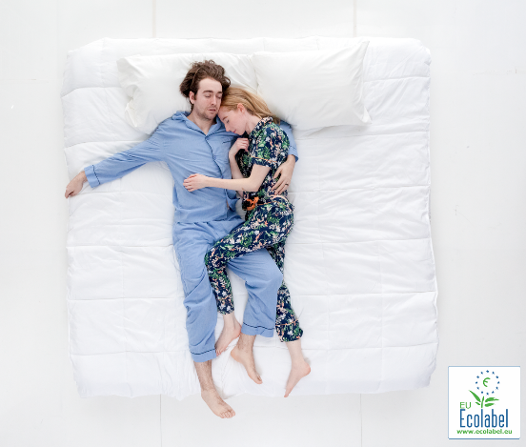
Current issue focus:  Product life cycle of bed mattresses  Tags:  #EUEcolabel  #CircularEconomy  #SustainableMaterials  # ProductLifeCycle | The #EU Ecolabel criteria pay attention to the whole product life cycle. To optimise bed mattresses end-of-life disposal, the products should be able to be taken apart, in order to easily repair or replace worn-out parts.  Manufacturers are also encouraged to sew rather than use glue when assembling products and prioritise removable covers.  More about our bed mattresses http://ec.europa.eu/ecat/ | The #EU Ecolabel criteria pay attention to the whole product life cycle. To optimise bed mattresses end-of-life disposal, the products should be able to be taken apart, in order to easily repair or replace worn-out parts. | 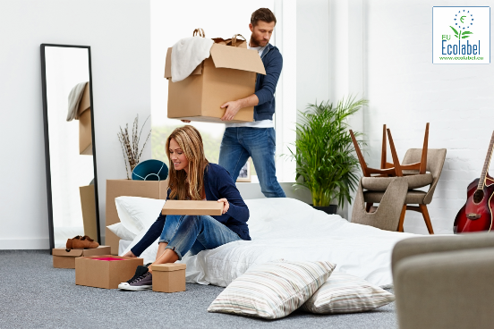

Social media tags, links and influencers

Feel free to use the following hashtags (#EUEcolabel, #CircularEconomy) and accounts in your social media posts in order to increase visibility of your posts.
Facebook influencers | @EUEnvironment ; @ZeroWasteFrance ; @EuropeanEnvironmentalBureau ; @AFNOR; @Montana Furniture; @Mobilferro @Elite;
Twitter influencers | @EU_ENV ; @bmoralesbailon (Blanca Morales); @Green_Europe (EEB) ; @beuc (BEUC) ; @AFNOR ; @ademe ; @ZeroWasteFR ;
Linkedin  Influencers | @EU Ecolabel ; @European Environmental Bureau; @BEUC; @Montana Furniture; @Mobilferro Srl; @Elite SA

Article - EU Ecolabel: supporting Europe’s green recovery with less harmful chemicals for bed mattresses

EU Ecolabel: supporting the European Green Deal and Europe’s green recovery with less harmful chemicals for bed mattresses
Supporting Europe’s green recovery and the European Green Deal’s ambition towards a toxic-free environment is a priority for the EU Ecolabel. Providing a framework for limiting the degradation of the environment during the production of bed mattress is an example. A particular focus on reducing the presence of toxic substances in the criteria helps fight water and air pollution within this industry.
Conventional mattress foams usually made of synthetic latex can be harmful for human health and the environment as they often contain toxic substances. The EU Ecolabel criteria tackle this issue by setting ambitious thresholds limiting the amount of hazardous substances if latex foam contributes to more than 5% of the total weight of the mattress. To limit toxic chemicals in wastewater discharges, yarns and fabrics used in EU Ecolabel products cannot have been bleached using chlorine agents. Also, dyes used must have a limited number of toxic substances within their formulas.
Furthermore, foams composed of polyurethanes often release Volatile Organic Compounds in the atmosphere, which can induce irritations to eyes and breathing problems. The EU Ecolabel criteria for bed mattresses restrict the amount of harmful chemicals emitted during the whole lifecycle of the products, while guaranteeing high-quality and optimal performance for end-consumers. For example, heavy metal concentration in polyurethanes foam must not exceed a certain threshold, which ensures healthier products for users.

These criteria contribute to preserving the environment as much as possible, while ensuring the well-being of workers and communities surrounding production plants. The EU Ecolabel also makes it possible for European citizens to choose healthier and safer products and contributes to the European Green Deal’s “zero pollution action plan for air, water and soil” that will be adopted in 2021 – further supporting Europe in a new post-pandemic reality.

Sources:
https://ec.europa.eu/info/sites/info/files/european-green-deal-communication_en.pdf
https://ec.europa.eu/environment/ecolabel/documents/bed_mattresses.pdf
https://eur-lex.europa.eu/legal-content/EN/TXT/?uri=OJ:JOL_2014_184_R_0009

